Task1

Name – Tejas Jambhale

Reg No. – 17BCE0861

Paragraph taken - **William Shakespeare** ([bapt.](https://en.wikipedia.org/wiki/Baptism" \o "Baptism) 26 April 1564 – 23 April 1616)[[a]](https://en.wikipedia.org/wiki/William_Shakespeare" \l "cite_note-2) was an English poet, playwright, and actor, widely regarded as the greatest writer in the English language and the world's greatest dramatist.[[2]](https://en.wikipedia.org/wiki/William_Shakespeare#cite_note-FOOTNOTEGreenblatt200511-3)[[3]](https://en.wikipedia.org/wiki/William_Shakespeare#cite_note-FOOTNOTEBevington20021%E2%80%933-4)[[4]](https://en.wikipedia.org/wiki/William_Shakespeare#cite_note-FOOTNOTEWells1997399-5) He is often called England's [national poet](https://en.wikipedia.org/wiki/List_of_national_poets) and the "Bard of Avon" (or simply "the Bard").[[5]](https://en.wikipedia.org/wiki/William_Shakespeare#cite_note-FOOTNOTEDobson1992185%E2%80%93186-6)[[b]](https://en.wikipedia.org/wiki/William_Shakespeare#cite_note-8) His extant works, including [collaborations](https://en.wikipedia.org/wiki/William_Shakespeare%27s_collaborations), consist of some [39 plays](https://en.wikipedia.org/wiki/Shakespeare%27s_plays),[[c]](https://en.wikipedia.org/wiki/William_Shakespeare#cite_note-9) [154 sonnets](https://en.wikipedia.org/wiki/Shakespeare%27s_sonnets), two long [narrative poems](https://en.wikipedia.org/wiki/Narrative_poem), and a few other verses, some of uncertain authorship. His plays have been translated into every major [living language](https://en.wikipedia.org/wiki/Modern_language) and are performed more often than those of any other playwright.[[7]](https://en.wikipedia.org/wiki/William_Shakespeare#cite_note-FOOTNOTECraig20033-10)

Shakespeare was born and raised in [Stratford-upon-Avon](https://en.wikipedia.org/wiki/Stratford-upon-Avon), [Warwickshire](https://en.wikipedia.org/wiki/Warwickshire). At the age of 18, he married [Anne Hathaway](https://en.wikipedia.org/wiki/Anne_Hathaway_(wife_of_Shakespeare)), with whom he had three children: [Susanna](https://en.wikipedia.org/wiki/Susanna_Hall) and twins [Hamnet](https://en.wikipedia.org/wiki/Hamnet_Shakespeare" \o "Hamnet Shakespeare) and [Judith](https://en.wikipedia.org/wiki/Judith_Quiney). Sometime between 1585 and 1592, he began a successful career in London as an actor, writer, and part-owner of a [playing company](https://en.wikipedia.org/wiki/Playing_company) called the [Lord Chamberlain's Men](https://en.wikipedia.org/wiki/Lord_Chamberlain%27s_Men), later known as the [King's Men](https://en.wikipedia.org/wiki/King%27s_Men_(playing_company)). At age 49 (around 1613), he appears to have retired to Stratford, where he died three years later. Few records of Shakespeare's private life survive; this has stimulated considerable speculation about such matters as [his physical appearance](https://en.wikipedia.org/wiki/Portraits_of_Shakespeare), [his sexuality](https://en.wikipedia.org/wiki/Sexuality_of_William_Shakespeare), [his religious beliefs](https://en.wikipedia.org/wiki/Religious_views_of_William_Shakespeare), and whether the works attributed to him were [written by others](https://en.wikipedia.org/wiki/Shakespeare_authorship_question).[[8]](https://en.wikipedia.org/wiki/William_Shakespeare#cite_note-FOOTNOTEShapiro2005xvii%E2%80%93xviii-11)[[9]](https://en.wikipedia.org/wiki/William_Shakespeare#cite_note-FOOTNOTESchoenbaum199141,_66,_397%E2%80%93398,_402,_409-12)[[10]](https://en.wikipedia.org/wiki/William_Shakespeare#cite_note-FOOTNOTETaylor1990145,_210%E2%80%93223,_261%E2%80%93265-13)

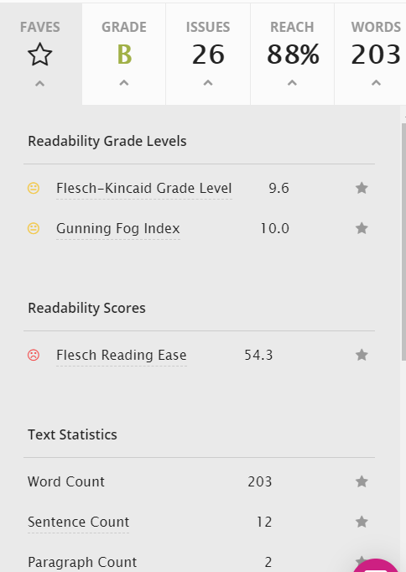 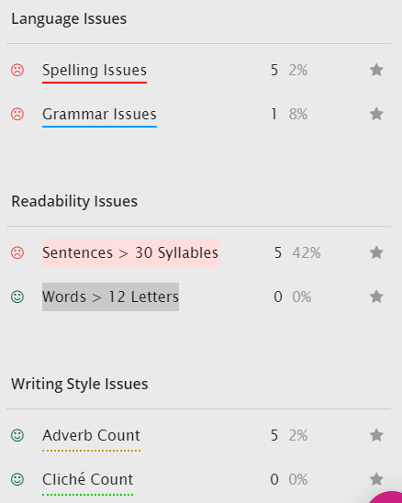

Even a wikipedia article has a readablity score B with 26 issues. Issues like Sentences>30 Syllables are found in most wikipedia articles which causes the poor score

Parameters are -



